Digital Canvas

Research Phase

These researches include relerant technology to the project.

In order to master the knowledge behind the scene, we separate the work and allocate to each team member

Pio:

Heads-up user-interface

Projection

Evan:

Open-frameworks examples and API

Github

Alastair:

Motion capture

Ben:

Gesture Recognition

OpenGL 3D Graphics

## Heads-up user-interface (Pio)

A heads-up display is a transparent or miniaturized display technology that presents data without requiring users to shift their gaze away from where their natural viewpoint was. A HUD should not be obstructing the user’s view, therefore projected or reflected transparent displays are utilized so that whatever is projected remains in the user’s line-of-site. In some cases, non-transparent screens may be used as long as they are unobtrusive (not attracting attention)

The origin of the name comes from pilots being able to view information with their heads “up” and looking forward, instead of looking down at an angle to their dashboard.

HUD may be fixed onto something e.g a device put below the car windscreen so that is it reflected; or head-mounted (or helmet-mounted) displays (HMDs) which is a type of projection which displays on the front of a helmet and moves with the orientation of the user’s head.

Examples of HUD use:

Gaming

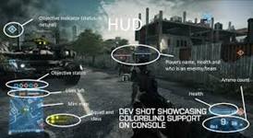

For Pilots

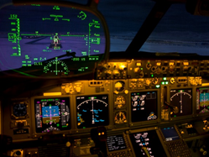

Car (navigation speedometer)

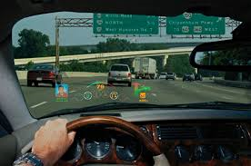

Ironman



## Projection (Pio)

Projection refers to the displaying of images by using a device. Devices relevant to our project may be a digital projector and/or a projection screen (I put and/or as we could either use a projection screen or use a blank wall?).

Digital projector (or a video projector) receives video signals then projects the corresponding image on to a projection screen using a lens system. They are commonly used for presentations, classroom training, theatres or concerts.

Projection screens are made up of a surface and a support structure. They can be permanently installed like a movie theatre or even painted on the wall. Some types can be semi-permanent or mobile, used in conference rooms or outdoor areas.

## Open-frameworks examples and API (Evan)

OpenFrameworks is an [open source](http://openframeworks.cc/about/license.html) [C++](https://en.wikipedia.org/wiki/C%2B%2B) toolkit designed to assist the creative process by providing a simple and intuitive framework for experimentation. The toolkit is designed to work as a general purpose glue, and wraps together several commonly used libraries, including:

* [OpenGL](http://www.opengl.org/), [GLEW](http://glew.sourceforge.net/), [GLUT](http://www.opengl.org/resources/libraries/glut/), [libtess2](https://code.google.com/p/libtess2/) and [cairo](http://cairographics.org/) for graphics
* [rtAudio](http://www.music.mcgill.ca/~gary/rtaudio/), [PortAudio](http://www.portaudio.com/), [OpenAL](http://http/connect.creativelabs.com/openal) and [Kiss FFT](http://kissfft.sourceforge.net/) or [FMOD](http://www.fmod.org/) for audio input, output and analysis
* [FreeType](http://freetype.sourceforge.net/index2.html) for fonts
* [FreeImage](http://freeimage.sourceforge.net/) for image saving and loading
* [Quicktime](http://developer.apple.com/quicktime/), [GStreamer](http://gstreamer.freedesktop.org/) and [videoInput](https://github.com/ofTheo/videoInput) for video playback and grabbing
* [Poco](http://pocoproject.org/) for a variety of utilities
* [OpenCV](http://opencv.org/) for computer visions
* [Assimp](http://assimp.sourceforge.net/) for 3D model loading

**https://github.com/saynono/ofxIsadoraKinect**a small plugin for isadora using openframeworks and ofxKinect to get the Kinect running inside of isadora.

Isadora  
The award-winning, real-time media manipulation software to create stunningly interactive visuals, sounds, and environments. Not a free product - licence starts at $350

## Motion capture (Alastair)

Motion capture is a way to digitally record human movements. The captured data is mapped to a digital model in 3D software.

Motion capture technology can be used in many ways including film, games, TV, and entertainment.

## Interesting Kinect + motion capture projects

KinectToPin

KinectToPin is a motion capture technology that can use gathered data from a Kinect to make animation in AfterEffects.

http://www.kinecttopin.com/kinecttopin/

## Gesture Recognition (Ben)

### Introduction

Gesture recognition is commonly originate from the face and hand. Gesture recognition can be conducted with techniques from computer vision and image processing. The literature includes ongoing work in the computer vision field on capturing gestures or more general human pose and movements by cameras connected to a computer

There is another technology called pen computing which is not only going to reduce the hardware impact of the system but also increase the range of usage of physical world object instead of digital object like keyboards and mouse. Using this kind of technology, human can implement a new thesis of creating of new hardware no requirement of monitors. This idea leads us to create a holographic display.

### Gesture types

In computer science, two types of the gestures are identified. In one hand, online gesture is considered as direct manipulations, such as scaling and rotating. On the other hand, offline gestures are usually processing after the interaction is finished. For example, a circle is drawn to activate the menu button.

### Input Devices

In digital canvas project context, the input devices include Webcam and Kinect. We will mainly focus on these later on.

### Methodology of programming

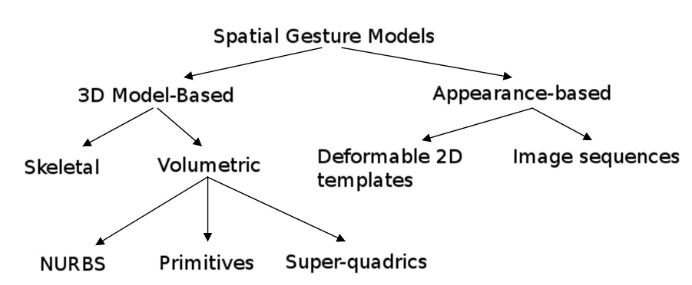

Diagram 1

### Algorithms

3D coordinate system provides a high accuracy of gestures. However, it also depends on the quality of the input data. Some literature differentiates 2 different approaches in gesture recognition: a 3D model based and an appearance-based. On the other hand, Appearance-based systems use images or videos for direct interpretation.

### Challenges

There are many challenges associated with the accuracy and usefulness of gesture recognition software. For image-based gesture recognition there are limitations on the equipment used and image noise. Images or video may not be under consistent lighting, or in the same location. Items in the background or distinct features of the users may make recognition more difficult.

The variety of implementations for image-based gesture recognition may also cause issue for viability of the technology to general usage. For example, an algorithm calibrated for one camera may not work for a different camera. The amount of background noise also causes tracking and recognition difficulties, especially when occlusions (partial and full) occur. Furthermore, the distance from the camera, and the camera's resolution and quality, also cause variations in recognition accuracy.

In order to capture human gestures by visual sensors, robust computer vision methods are also required, for example for hand tracking and hand posture recognition or for capturing movements of the head, facial expressions or gaze direction.

Diagram 2 Interaction between Human body movement (input) and output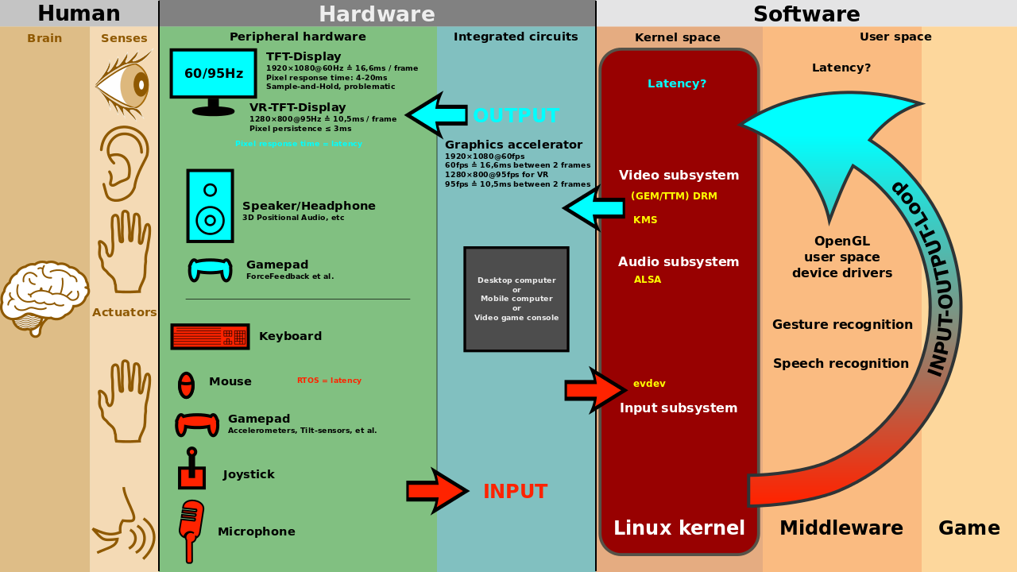

Reference: Gesture recognition http://en.wikipedia.org/wiki/Gesture_recognition

## OpenGL 3D Graphics (Ben)

OpenGL is a cross-language, multi-platform application programming interface (API) for rendering 2D and 3D vector graphics. The API is typically used to interact with a graphics processing unit (GPU), to achieve hardware-accelerated rendering.

In this project, the client is using Xcode in C++ as his running platform. In graphical part, we may need to modify some of the existing codes as well as the structure in order to fit in the motion capture.

Here is the tutorial for us to learn Xcode with OpenGL.

http://lnx.cx/docs/opengl-in-xcode/